INTRODUCTION TO EXPERIMENTAL DESIGN
01:960:490:01

SECOND EXAM SPRING 2020

ANSWER PAGE (to be uploaded into CANVAS)

1. (a) Sketch the interaction plot

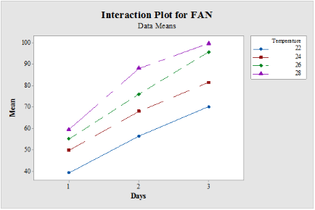

1. (b) The ANOVA table is

SoV df SS MS F p
Days 2 5176.60 2588.3 119.28 0.00
Temperature 3 2518.00 2593.9044 129.30 0.00
Interaction 6 142.00 23.67 1.09 0.00
Error 12 260.38 20.0613
Total 23 8096.98

1. (c) Write the final model that you recommend after this ANOVA analysis:

We will use the model that consist of days, temperature, and interaction, as they are all needed to describe the means

2. (a) What do you think is the objective of this experiment? (Please circle your answer)

(1) To find the conditions to kill the virus

(2) To find the conditions to increase the virus growth

(3) To find the conditions to decrease the virus growth

2. (b) Present an sketch of the interaction:
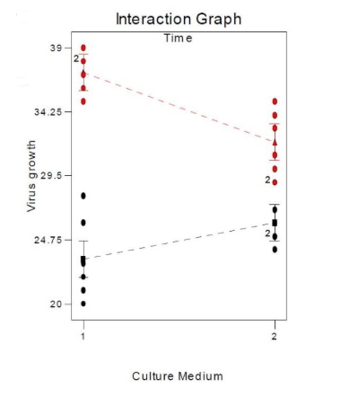

2. (c) Your conclusion from the ANOVA table and the interaction plot is: (please circle your answer)

(1) Factor B (Time) is the only significant factor that explains the viral growth.

(2) Factor B is significant, but its influence on the viral growth depends on Factor A.

(3) Factor A is significant since there is a significant interaction with Factor B.

2. (d) After an analysis of the residuals from fitting this 2² model with n = 6 your conclusion on data normality and constant variance is: (please circle your answer)

(1) The plots show data that is basically normal with constant variance

(2) The plots show data is normal, but a Shapiro-Wilk test is needed to test the
homogeneity of the variance since the residuals show a somewhat funnel
shape

(3) The plots show data is normal, but a Levene test is needed to test the
homogeneity of the variance since the residuals do not appear equally
dispersed at each predicted value

(4) The plots show data not perfectly normal, thus a normality test is needed
:

3.- (a) Then the number of blocks generated is 4
Since we have 2 interactions, number of blocks = 2x2 = 4
3.- (b) The generalized interaction that gets confounded is ABCD
Generalized interactions confounded = BCE x ADE = ABCD

BCE
1 | b
a | Ab
bc | C
abc | Ac
d | Bd
ad | Cd
bcd | Abd
abcd | Acd
be | E
ce | Ae
abe | De
ace | Ade
bde | Bce
cde | Abce
acde | Bcde
abde | Abcde

ADE
1 | a | b | ab
bc | abc | c | ac
ad | d | abd | bd
abcd | bcd | acd | cd
abe | be | ae | e
ace | ce | de | ade
bde | acde | abce | bce
cde | abde | bcde | abcde
3.- (c) If two of the blocks are: [a, d, abc, bcd, be, abde, ce, acde]
[(1), ad, bc, abcd, abe, bde ace, cde]

Then the next two blocks are

[b, c, abd, acd, ae, de, abce, bcde]

[ab, ac, bd, cd, e, ade, bce, abcde]

4. - (a) Which fraction and resolution is this experiment?

Fraction = 16 Resolution = 4

4. – (b) If the basic design is given by the factors A, B, and C, define the column for D using the minus and plus signs

ANS: number of observations = 2⁴⁻¹ = 8

Treatment contributor | A | B | C | D = -ABC
(1) | - | - | - | +
a | + | - | - | -
b | - | + | - | -
ab | + | + | - | +
c | - | - | + | -
ac | + | - | + | +
bc | - | + | + | +
abc | + | + | + | -

4. - (c) The alias of D is -ABC

and the alias of A is -BCD

4. – (d) If the estimate for A in this fraction is [A]’ = 19, what is the alias structure of this estimate?

[A]’ → A - BCD

4. – (e) If an estimate of A from the fraction obtained using the relation I = ABCD is [A] = 24.25, find the estimates of A and its alias.

Estimate for A = ½( Estimate obtained with I = ABCD + Estimate obtained with I = - ABCD)
= 21.63
.
Alias of A → A - BCD

INTRODUCTION TO EXPERIMENTAL DESIGN
01:960:490:01

SECOND EXAM SPRING 2020
Instructions:

1. Name: Himesh Buch & ID Number: hnb17
2. Check your exam: there are 5 problems. This is a personal exam.
3. Use the ANSWER page to collect all your answers; this should be uploaded into CANVAS.

1. – An experiment was conducted to determine the effect of germination time (in days) and temperature (degrees C) on the free alpha amino nitrogen (FAN) content of rice malt. The values shown in the following table are the treatment means of FAN with n = 2 replications.

Temperature
Days 22 24 26 28 Row Means
1 39.4 49.9 55.1 59.5 50.98
2 56.4 68.0 76.4 88.8 72.40
3 70.2 81.5 95.6 99.6 86.72
Col. 55.33 66.47 75.70 82.63 Overall Mean = 70.03
Means
(Col, = Column)

(a) Draw the interaction plot for these data. Present the sketch in the ANSWER page.

(b) Complete ANOVA table corresponding to these data. NOTE: write the missing numbers in the ANSWER page

SoV df SS MS F p
Days 2 5176.60 2588.3 119.28 ?
Temperature 3 2518.00 ? ? ?
Interaction 6 142.00 23.67 1.09 ?
Error 12 260.38 ?
Total ? ?

(c) Write the final model that you recommend after this ANOVA analysis on the ANSWER page.

2. - A bacteriologist is interested in the effects of two different culture media (Factor A) and two different times (Factor B) on the growth of a particular virus. She performs six replicates of a 2² design, making the runs in random order. The data and analysis of the virus growth is presented below together with an ANOVA table. Note: (numbers in parenthesis are totals for each cell)

Culture Medium
Time | 1 | 2
12 hrs. | 21, 22, 23, 28, 20, 26 (140) | 25, 26, 24, 25, 29, 27 (156)
18 hrs. | 37, 38, 35, 39, 38, 36 (223) | 31, 29, 30, 34, 33, 35 (192)

ANOVA Table:

Sum of Mean
SoV DF Squares Square F₀ P-value
A 1 9.38 9.38 1.84 0.1906
B 1 590.04 590.04 115.51 0.0001
AB 1 92.04 92.04 18.02 0.0004
Error 20 102.17 5.11
Total 23 793.63

a) What do you think is the objective of this experiment? (Please circle your answer on the ANSWER page)

(1) To find the conditions to kill the virus

(2) To find the conditions to increase the virus growth

(3) To find the conditions to decrease the virus growth

b) Draw the interaction plot. Present the sketch on the ANSWER page.

c) Your conclusion from the ANOVA table and the interaction plot is: (please circle your answer on the ANSWER page)

(1) Factor B (Time) is the only significant factor that explains the viral growth.

(2) Factor B is significant, but its influence on the viral growth depends on Factor A.

(3) Factor A is significant since there is a significant interaction with Factor B.

d) An analysis of the residuals from fitting the 2² model with n = 6 shows the following two plots:

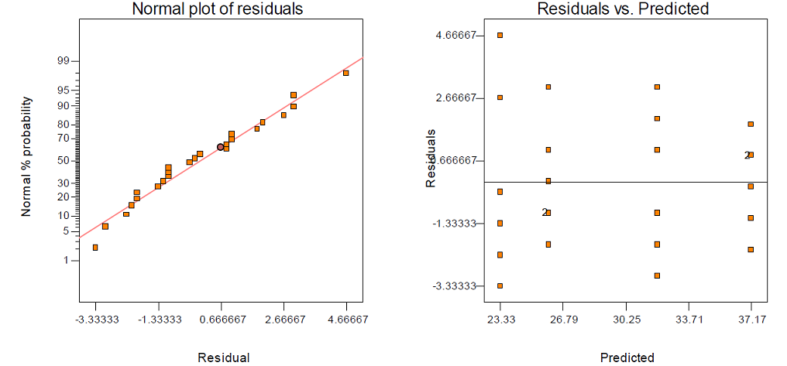

Then your conclusion on data normality and constant variance is: (please circle your answer on the ANSWER page)

(1) The plots show data that is basically normal with constant variance

(2) The plots show data is normal, but a Shapiro-Wilk test is needed to test the
homogeneity of the variance since the residuals show a somewhat funnel
shape

(3) The plots show data is normal, but a Levene test is needed to test the
homogeneity of the variance since the residuals do not appear equally
dispersed at each predicted value

(4) The plots show data not perfectly normal, thus a normality test is needed

3. - In a 2⁵ design with factors A, B, C, D and E, several blocks were generated by confounding the interactions BCE and ADE.
a) Then the number of blocks generated is ______________
b) The generalized interaction that gets confounded is _________________
c) If two of the blocks are: [a, d, abc, bcd, be, abde, ce, acde]
[(1), ad, bc, abcd, abe, bde ace, cde]

then the next two blocks are
_____________________________________

_____________________________________

4. - In a 2⁴ design with factors A, B, C and D, a fraction was generated using the defining relation
I = - ABCD.

a) Which fraction and resolution is this experiment?

Fraction = _________ Resolution = ________

b) If the basic design is given by the factors A, B, and C, define the column for D using the minus and plus signs

c) The alias of D is ________________

and the alias of A is ________________

d) If the estimate for A in this fraction is [A]’ = 19, what is the alias structure of this estimate?

[A]’ →

e) If an estimate of A from the fraction obtained using the relation I = ABCD is [A] = 24.25, find the estimates of A and its alias.

